Estimados compañeros/socios de AEMARK,
Con este boletín de abril de 2022 os hacemos llegar información sobre:
- 33rd Congreso Internacional de Marketing AEMARK 2022.
- Homenaje al profesor Rodolfo Vázquez Casielles.
- Special Issue Psychology & Marketing. “New horizons in customer experience: Exploring human embrace of Technologies 4.0 from a marketing perspective”.
- Special Issue Journal of Hospitality and Tourism Research. "Responsible Tourism and Hospitality".
- Società Italiana Marketing (SIM). Doctoral Colloquium (Bologna-June 2022).
- Call for papers: “Digitalization and Servitization in International Entrepreneurship”.
- 10th EIASM International Conference on Tourism Management & Related Issues Valencia (Spain), september 2022.
- 2nd International Workshop on Gammification and Motivational (GAMOTEC 2022).
- International Conference on Marketing and Technolgies. ICMarkTech'22.
- XXII Congreso Internacional AECIT 2022.
- Reconocimiento de nuestros compañeros: Nombramientos.

Un saludo,
Ángel Herrero Crespo

Ampliado el plazo para el envío de trabajos al 9 de mayo
Ampliado el plazo para el envío de ponencias, trabajos en curso, pósteres y propuestas para el Doctoral Colloquium al 33 Congreso Internacional de Marketing Aemark que se celebrará en Valencia del 7 al 9 de Septiembre.
Consulta toda la información sobre fechas clave y normativa de envío en la web del congreso.

33rd CONGRESO INTERNACIONAL DE MARKETING AEMARK 2022:
Jan-Benedict Steenkamp, keynote speaker.

The 33rd AEMARK Conference is pleased to announce the keynote speaker of the 2022 Conference.
Jan-Benedict Steenkamp is doctor honoris causa; PhD, MSc, BSc [all summa cum laude]. Professor Steenkamp is C. Knox Massey Distinguished Professor of Marketing at the University of North Carolina’s Kenan-Flagler Business School. Further details can be seen here https://www.jbsteenkamp.com/
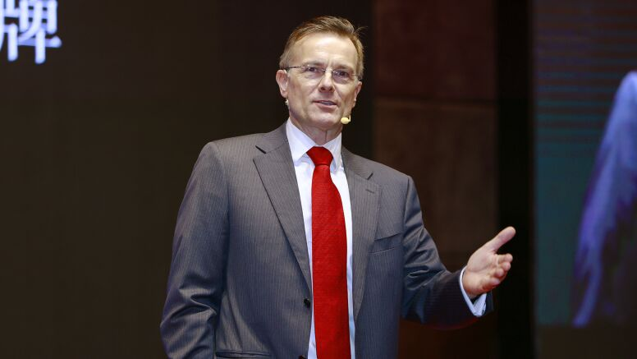

He has written over one hundred articles for leading marketing and management journals as well as leading practitioner outlets such as Harvard Business Review, Management and Business Review, Business Strategy Review, Long Range Planning, and Financial Times. His work has received more than 59,000 citations and he has a Hirsch index of 86. He has received multiple awards and distinctions, such as the 2013 EMAC Distinguished Marketing Scholar Award.
His latest book “Time to Lead: Lessons for Today’s Leaders from Bold Decisions that Changed History” provides lessons from leaders who span 2,500 years and come from China, France, Germany, Great Britain, Greece, Israel, South Africa, Spain and the U.S.
Do not miss this unique opportunity for listening to his inspiring ideas at the 33rd AEMARK Conference in Valencia.
Sponsored by
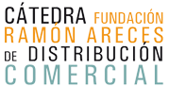

Homenaje al profesor Rodolfo Vázquez Casielles

El pasado día 1 de abril, en el Aula Magna de la Facultad de Economía y Empresa de la Universidad de Oviedo, tuvo lugar el acto homenaje al profesor Rodolfo Vázquez Casielles. En dicho acto participaron, además de la familia del profesor Vázquez Casielles y las autoridades de la Universidad de Oviedo y el Gobierno del Principado de Asturias, nuestros compañeros de AEMARK Juan Trespalacios y Yolanda Polo, que glosó “El legado del profesor Rodolfo Vázquez Casielles”. Cabe destacar también la presencia de numerosos compañeros de la Universidad de Oviedo y de otras universidades españolas, que hicieron patente la relevancia académica y calidad humana del homenajeado.
Así mismo, nuestro presidente Ángel Herrero, hizo entrega a la familia del Premio a la Trayectoria Académica en Marketing AEMARK. Dicho premio se concedió a título póstumo en 2020, pero no pudo ser entregado por la cancelación del Congreso AEMARK de ese año.
Reiteramos una vez más nuestro sentido recuerdo al profesor Vázquez Casielles y el homenaje de todos los que formamos parte de AEMARK.
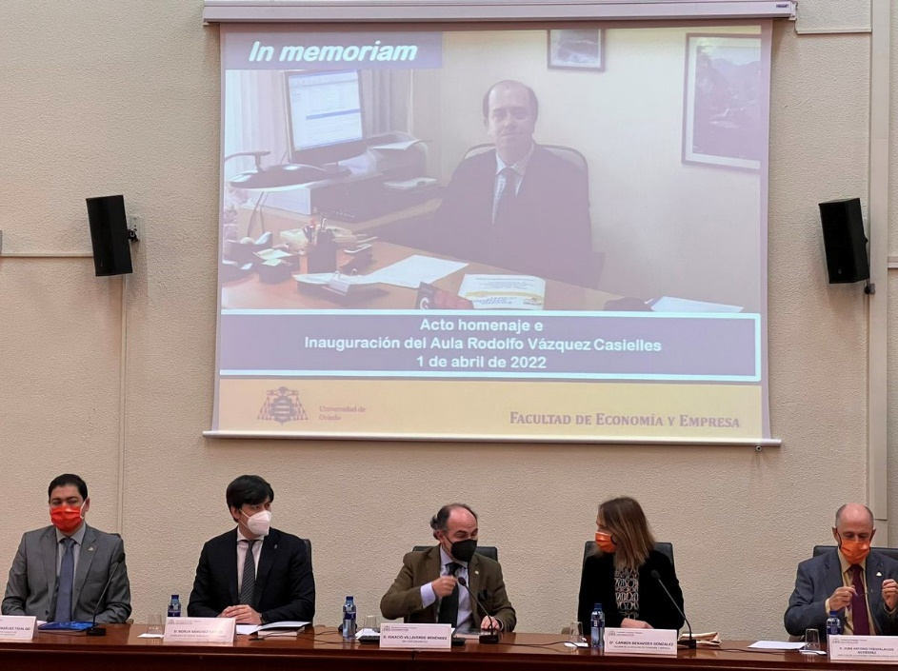

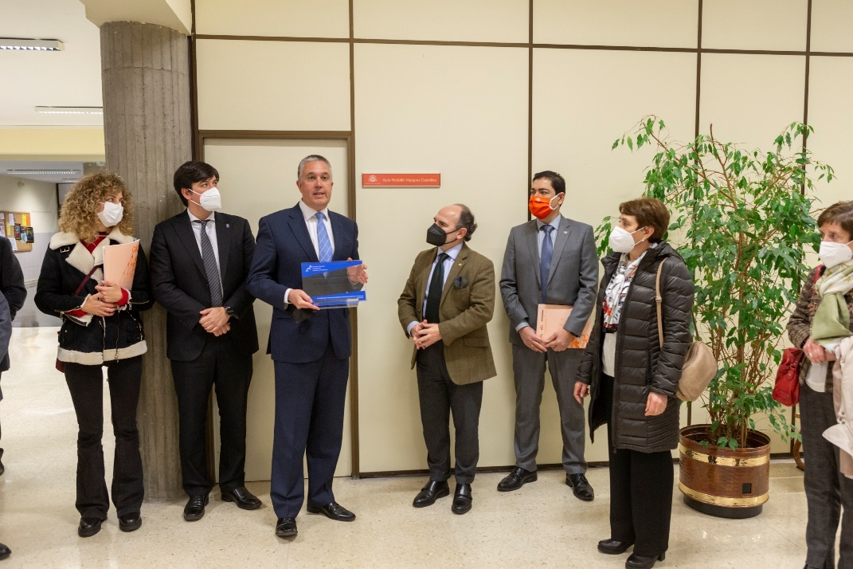

CALL FOR PAPERS

Special Issue Psychology & Marketing. “New horizons in customer experience: Exploring human embrace of Technologies 4.0 from a marketing perspective”
The fast and inexorable advancement of technology is affecting almost every aspect of the economy and the social relationships. Technologies 4.0 such as Artificial Intelligence (AI), robotics, virtual and augmented reality (VR/AR), the Internet of Things (IoT), Big Data or cloud computing are participating actively in the management of business, the labor market and the daily activity of ordinary people. For instance, analytical AI and sophisticated algorithms based on Big Data are deciding Amazon’s product assortment on customers’ screens but also the best route for shipments, the rider that is contracted to deliver food, or the newsfeeds that a user of social media watch early in the morning.
Although the impact of Technologies 4.0 is commonly thought of in sectors such as logistics, banking or tourism, their potential for marketing operations is particularly remarkable across industries. The increasing digitalization and the multiple touchpoints of the data-driven customer journey lead marketing managers rely on these technologies to better shape their customer relations. There is a need to better understand why people are more or less willing to adopt, interact with and integrate such technologies in their daily routines. Additionally, ethical issues regarding the replacement of persons by technology or the combination of both together clearly deserve further research attention. A highly intense reliance on technology may lead to a ubiquitous surveillance and even to practices of social engineering in which individuals are continuously rated at any task in their lives as citizens or customers.
This Special Issue offers a platform to scientifically explore and discuss the growing relevance of Technologies 4.0 in business and society by better understanding the psychological factors contributing to a safe and successful embrace of these technologies by consumers. Both conceptual and empirical work concerned with a technological enhancement of customers’ experience are welcomed. Articles considered for the Special Issue may focus on topics including, but not limited to, the following research questions:
- Which features of Technologies 4.0 represent an opportunity for implementing marketing actions by managers?
- How do customers’ and employees’ perceptions and reactions toward these features differ?
- Which psychological theories are better able to explain customer embrace or rejection of Technologies 4.0?
- How do users integrate these technologies in their lives and what are the differences from previous non-smart technologies?
- How can Technologies 4.0 advancements improve brand positioning and marketing performance along the customer journey?
- How should these technologies be implemented in companies to enhance customer experience?
- What are the main challenges and opportunities of employing Technologies 4.0 in specific sectors such as retailing, frontline services or social media management?
- What influences consumers’ perception and engagement with the metaverse?
- How is technology innovation affecting the customer-provider relationship in the short and long term?
- How should companies manage Technologies 4.0 and respond to customer data privacy protection behavior?
- What are the main ethical and moral issues related to Technologies 4.0?
- What is the role of this technological transformation in promoting or demoting social equality?
Guest Editors:
- Russell Belk (York University; Canada) rbelk@schulich.yorku.ca
- Carlos Flavián (University of Zaragoza; Spain) cflavian@unizar.es
- Daniel Belanche (University of Zaragoza; Spain) belan@unizar.es
- Park Thaichon (Griffith University; Australia) p.thaichon@griffith.edu.au
Submission deadline:
1 December 2022 (early submission will be appreciated)
To submit a manuscript, follow the manuscript submission guidelines outlined in the "Instructions for Authors" of Psychology & Marketing, be sure to select the correct Special Issue and also mention it in the letter to the editor.
Prospective authors are encouraged to participate in the preparatory conference AIRSI2022 by presenting the preliminary versions of their papers and contact the guest editors for any specific comment or question (cflavian@unizar.es).
Link to the full version of the call for papers:
https://onlinelibrary.wiley.com/journal/15206793

Special Issue Journal of Hospitality and Tourism Research. "Responsible Tourism and Hospitality"
Amid the environmental, economic, and socio-cultural growth of tourism development, sustainability has become a key concern for all the stakeholders of society. In the UNWTO’s 2030 Agenda for Sustainable Development and the Sustainable Development Goals, ending extreme poverty, fighting inequality and injustice, and fixing climate change are the key themes. As one of the largest and fastest-growing economic sectors in the world, tourism has grown at all levels through job creation, agricultural productivity spur, health care provision, pollution control, environmental conservation, and responsible consumption and production.
Recent research shows that sustainable tourism development enhances the prosperity of tourism destinations (Falatoonitoosi et al., 2021); environmental management is beneficial to lodging firms’ financial performance (Yeon et al., 2021); and properly designed marketing tools can increase customer engagement in prosocial initiatives (Gao et al., 2020) and encourage pro-environmental behavior (Wu et al., 2021). In addition, previous research suggests that online reviews of responsible tourism destinations are rated high in perceived helpfulness, perceived influence, and brand equity (Bigné et al., 2020). Given the impacts of the environmental, societal, and regulatory initiatives in the tourism and hospitality industry, this special issue of JHTR seeks to bring together a wide range of research to assess and illuminate how responsible tourism and hospitality industry contributes to the welfare and sustainability of the world.
The focus of this special issue is on “responsible” initiatives that emphasize the impact of marketing, consumer behavior, accounting and finance, strategy, human resources, technology, supply chain, food and beverage, planning and design on the tourism and hospitality industry. In line with the guiding editorial principles of JHTR, we expect to publish Innovative, Meaningful, Practically relevant, Academically rigorous, Cross-disciplinary, and Theory-focused research using a variety of methods such as quantitative, qualitative, or mixed-method/multi-method. In particular, this special issue seeks systematic literature syntheses, meta analyses, seminal theory-building efforts, scale development and validation studies, or innovative research designs that relate to the responsibility of the hospitality and tourism industry. The topics include but are not limited to:

- Sustainable/green/cause-related marketing in tourism and hospitality
- Consumer ethical behavior in tourism and hospitality
- Carbon offsetting and carbon neutrality in tourism and hospitality
- Green finance in tourism and hospitality
- Corporate social responsible strategies in tourism and hospitality
- Ethical leadership and ethical human resource management in tourism and hospitality
- Environmental/green/clean technology in tourism and hospitality
- Sustainable supply chain in tourism and hospitality
- Green practices in food and beverage management
- Sustainable planning and design in tourism and hospitality

Timeline and Submission Procedure:
All submitted manuscripts will be assessed by the guest editors who determine suitability for review at JHTR. The review process is double-blind.
- Full paper submissions: August 2022. Revisions and decisions: September 2022 - December 2022.
- Publication: in 2023
Guest Editors
- Anna Mattila, PhD, School of Hospitality Management, Penn State University, USA.
- Lisa Gao, PhD, School of Hotel and Tourism Management, The Hong Kong Polytechnic University, Hong Kong.
- Luisa Andreu, PhD, School of Economics, Department of Marketing, University of Valencia, Spain.
More information:
https://journals.sagepub.com/page/jht/cfp-responsible-tourism-hospitality

Journal of International Entrepreneurship. “Digitalization and Servitization in International Entrepreneurship”
The Journal of International Entrepreneurship welcomes submissions for a special issue exploring the creation and deployment of digital dynamic capabilities in the digitized international entrepreneurial ventures enabling to enter and compete effectively in the rapidly expanding online global marketplace.
The purpose of this special issue is to shed new light on how international entrepreneurial ventures (IEVs) support customer demands and requirements in international markets by developing digitalized and/or servitized business models and their respective impacts on their international growth and performance. We invite researchers to submit conceptual and empirical papers on issues addressing digitalization and servitization in IEVs. Specifically, this issue invites papers that advance knowledge on the micro-foundations that deploy DDC and digitalized business models under which a service logic emerges, develops and is implemented by IEVs, especially for those not born in the on-line context. It would be also interesting for papers to further highlight the problems and challenges associated with enacting digitalization and/or servitization in IEVs by the way of DDC deployment and their impact on growth. Other interesting inquiries can address the circumstances in the IEVs’ external environment under which digital and servitized business models are demanded and how external forces interact with internal processes. Multidisciplinary papers are also well received. Consequently, potential topics include, but are not limited to:
- Levels of analysis of digitalization and DDC in international entrepreneurship research and differences between digital IEVs and non-digital IEVs.
- Different practices that enhance DDC in the context of digital IEVs and non-digital IEVs and their consequential impact on their performance (e.g. international extent, scope, and speed, international performance, innovation performance).
- Similarities and differences in digitalization across domestic/international market operations. Conceptual and empirical discrepancies between born-digital IEVs and non-digital IEVs.
- Defining, adapting, measuring and comparing different digitalised and/or servitized business models in IEVs.
- Antecedents and conditions that enable or disable the adoption and implementation of digital business models or servitization in the context of international entrepreneurship.
- Different paths for evolving transition along the product-to-service continuum in the context of IEVs and their impact on their performance.
- Interactions between servitization and digitalization in response to international opportunities or to global crisis for IEVs.
- The service paradox in the context of IEVs and the role of digitalization and other internal capabilities to overcome the service paradox.
- Servitization impact in early and rapid internationalization, and foreign entry mode selection (e.g. Internet; foreign agents and distributors, IJVs, FDI, alliances and/or networks).
Submission guidelines
- Prospective authors are encouraged to submit one-page synopsis by e-mail to the SI guest co-editors no later than June 30, 2022.
- Please visit the Journal of International Entrepreneurship and click on Submission guidelines for format and styling instructions. Please submit your full manuscript via http://www.editorialmanager.com/jien no later than November 30, 2022.
- If asked whether you are submitting to a special issue, reply “Yes” and select the relevant title from the drop-down menu. We recommend that you mention that you are submitting to this special issue in your cover letter as well.
- Submitted contributions should not have been previously published nor be currently under consideration for publication elsewhere. Manuscripts will undergo rigorous peer review through the journal’s double-blind peer review process.
Guest Editors (by alphabetical order):
Andreu Blesa Universitat Jaume I de Castelló, Spain. Email: blesa@uji.es
Alex Rialp Universitat Autònoma de Barcelona, Spain. Email: Alex.Rialp@uab.cat
Josep Rialp Universitat Autònoma de Barcelona, Spain. Email: Josep.Rialp@uab.cat
Maria Ripollés Universitat Jaume I de Castelló, Spain. Email: maria.ripolles@uji.es

Società Italiana Marketing (SIM). Doctoral Colloquium (Bologna-June 2022)

La Società Italiana de Marketing ofrece a los estudiantes de doctorado, la participación en el Doctoral Coloquium, que tendrá lugar en la Universidad de Bologna los días 3 y 4 de junio de 2022.
El evento hace posible que los estudiantes de doctorado tengan un lugar para reunirse y discutir sus proyectos de investigación con académicos líderes en el área de marketing.
El Doctoral Coloquium da la bienvenida a una amplia gama de temas, aplicaciones y métodos en marketing, con el objetivo de apoyar a los jóvenes académicos tanto en etapas tempranas como avanzadas, para el fortalecimiento de la relevancia teórica, metodológica y práctica de su investigación. Esto se hará estimulando el debate tanto con los profesores como con los compañeros de doctorado.
Fechas clave:
- Envio de propuestas de investigación: Fecha extendida 14 abril 2022.
- Notificación a los autores: 26 abril 2022
- Registro: 6 mayo 2022
- Realización Doctoral Colloquium 3 y 4 junio 2022.

Más información: http://www.simktg.it/sp/doctoral-research-colloquium.3sp.

10th EIASM International Conference on Tourism Management & Related Issues Valencia (Spain) september 2022.

Over the last six decades, tourism has experienced continued expansion and diversification, becoming one of the largest and fastest-growing economic sectors in the world (United Nations World Tourism Organization, 2018).
More specifically, in spite of sporadic shocks, international tourist arrivals have recorded a virtually uninterrupted increase: from 277 million in 1980 to 1.4 billion in 2018.
The United Nations World Tourism Organization (UNWTO) in its long-term outlook of future tourism trends (Tourism Towards 2030) estimates that international arrivals worldwide are expected to reach nearly 1.8 billion by the year 2030.
A number of major factors can explain this dramatic increase in demand for tourism: (1) the process of globalization; (2) the development of mass transportation and motorization (and the parallel decrease in cost of transportation due to improvements in technology); (3) the rhythm of increase of world GDP as well as the increase of income to be allocated to travels; (4) the introduction of new ICT applications in the work of public and private stakeholders in the tourism sector; (5) the general improvement of security and rights for tourists.
Every and each of the abovementioned factors is significantly contributing to shaping a different institutional landscape and economic environment for a number of economic players such as Convention Bureaus, Professional Conference Organizers, Destination Management Companies, Airlines, Hotels, Conference Venues, Congress Centers, Convention Centers, Exhibition Centers. Moreover, companies in the tourism sector are confronted with increasing managerial challenges and have to deal with a turbulent and fast changing environment.
We invite contributions that focus especially, but not exclusively, on tourism, travel, leisure and hospitality management, with an emphasis on:

- Hospitality management
- Destination management & marketing
- Congress management
- MICE
- Air transportation management
- Antecedents of tourism collaboration
- Archaeological sites management
- World Heritage and intangible cultural heritage management
- Urban and regional tourism planning
- Tourism policies
- Inter-organizational dynamics (e.g., mergers and acquisitions, joint venture, strategic alliances, coopetitive strategies, etc.) in the tourism sector
- Tourism marketing
- Consumer behaviour and customer satisfaction
- Online consumer behaviour and eWOM
- Renewable sources of energy and tourism
- Glocalisation: managing the global and the local in the tourism industry
- Human resources management
- Ecotourism and sustainable tourism development
- Entrepreneurship and SMEs
- Performance management
- Revenue management
- ICT and tourism
- Virtual and augment reality in tourism
- Big data and business intelligence
- Robots in tourism
- Artificial intelligence
- Automation
- CSR
- Sharing economy and tourism
- Managing the skies: air transportation

The topics reported above are indicative and informative rather than exclusive. Other interesting work on tourism management and related issues that is not closely related to the themes above will be taken into consideration.
Co-chairs:
- Enrique Bigné (University of Valencia).
- Luisa Andreu (University of Valencia).
- Iis Tussyadiah (University of Surrey, UK).
- Marcello Mariani (University of Reading, UK).
Guest speakers:
- Cathy Hsu (The Hong Kong Polytechnic University, Hong Kong); Editor of Tourism Management.
- Luiz Moutinho (University of Suffolk, UK & University of the South Pacific, Fiji).
Submission deadline:
Interested scholars should submit a 3 pages structured extended abstract (of around 1,500 words) including the following:
- Title
- Purpose
- Design/methodology/approach
- Preliminary findings
- Theoretical contribution and practical implications
- Originality/value
- Keywords
- References
The Submission deadline for the extended abstract is 15 May 2022.
In case of acceptance, full papers will be requested by August 30, 2022.
Further info:
https://www.eiasm.org/frontoffice/event_announcement.asp?event_id=1450

2nd International Workshop on Gammification and Motivational (GAMOTEC 2022)

The University of Zaragoza (Spain) and the GENERES research group are proud to host the 2nd International Workshop on Gamification and Motivational Technologies (GAMOTEC 2022), September 5-6, 2022. This workshop is aimed at academic researchers and practitioners seeking to advance knowledge in the field of gamification.
GAMOTEC 2022 will be held online and participation is free of charge.
Researchers interested in participating in the workshop are invited to submit an extended abstract (between 1,000 and 2,000 words) of their academic works to email address: gamotec@unizar.es
Important dates:
- Submissions deadline: June 20, 2022
- Notification of acceptance: July 31, 2022
- Registration: August 28, 2022
- Celebration dates: September 5-6, 2022
GAMOTEC 2022 welcomes theoretical and empirical submissions related to the gamification phenomenon and motivational technologies. Topics of interest for this workshop include, but are not limited to:
- Gameful experience, motivation, flow, engagement, meaningful gamification.
- Gamification design, design methods, game mechanics, game dynamics, motivational affordances.
- Gamification in marketing, advergaming, gamified loyalty programmes, social media and gamification.
- Gamification in education, game-based learning, serious games, simulation games.
- Work gamification, gamified recruitment, gamification in leadership, gameful work.
- Games and gamification for health, exergames, quantified self.
- Green gamification, sustainable gamification.
- Gamification in tourism, eSports.
- Motivational technology, virtual reality, augmented reality, wearables, artificial intelligence, privacy, security.
- Player/user types.
- Side-effects and long-term effects of gamification.
- The societal impacts and ethical issues of gamification.
More information:
https://eventos.unizar.es/63018/detail/international-workshop-on-gamification-and-motivational-technologies-gamotec.html

International Conference on Marketing and Technolgies. ICMarkTech'22
Se encuentra abierto el plazo para el envío de ponencias al 2022 International Conference on Marketing and Technologies que se celebrará en la Facultad de Ciencias Económicas y Empresariales de la Universidade de Santiago de Compostela (España) entre el 1 y el 3 de diciembre de 2022.
El evento contará como conferenciantes invitados, con el Prof. Flavián, de la Universidad de Zaragoza, y la Prof. Plassmann, del INSEAD.
Aspectos clave:
- Hasta el Sep 09, 2022 se pueden enviar los trabajos para su evaluación por el Comité Científico.
- Los trabajos pueden estar escritos en inglés, español o portugués. Todos los trabajos serán sometidos a una "double-blind review" por al menos dos miembros del Comité Científico, con base en la relevancia, originalidad, importancia y claridad.
- Los trabajos escritos en inglés, aceptados y registrados se publicarán en Proceedings by Springer en un libro de la série SIST, se presentarán para su indexación por ISI, EI-Compendex, SCOPUS y Google Scholar, entre otros, y estarán disponibles en SpringerLink Libreria digital.
- El mejor trabajo que cumpla con el ámbito de la revista se beneficiará de un fast track en el "European Journal of Management and Business Economics", que está indexado en WoS/ESCI, Scopus, entre otros, con IF 0.75 (JCI, 2020) y clasificado como Q2 (Scopus, 2020) en las áreas de Business and International Management, Finanzas, Marketing, Organizational Behavior and Human Resource Management, Strategy and Management, y Tourism, Leisure and Hospitality Management.
- Los dos mejores trabajos que cumplan con el ámbito de la revista serán publicados en la revista "Cogent Business and Management", que está indexada en WoS/ESCI, Scopus, CABS, entre otros, con IF 0.35 (JCI, 2020) y clasificada como Q2/Q3 (Scopus, 2020) en las áreas de Contabilidad, Negocios y Gestión Internacional, Ciencia de la Gestión e Investigación Operativa, Marketing, Comportamiento Organizacional y Gestión de Recursos Humanos, y Estrategia y Gestión.
Más información en http://www.icsporto.com/icmarktech/index.php/en/

XXII Congreso Internacional AECIT 2022. El nuevo turismo: Innovación, Digitalización, Sostenibilidad y Competitividad.
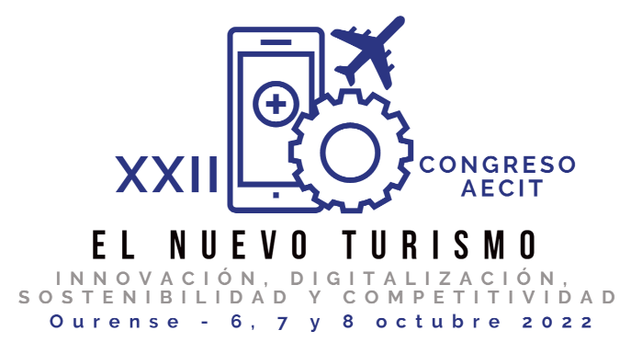

Se encuentra abierto el plazo para el envío de resúmenes al Congreso Internacional de AECIT 2022, a celebrar los días 6 a 8 de octubre en Ourense.
El XXII Congreso pretende dar continuidad a un evento científico consolidado y de gran relevancia que facilita cada dos años el encuentro de académicos e investigadores, responsables de la planificación y gestión pública, y empresarios del turismo.
Áreas científicas:
- Administraciones públicas y turismo
- Gestión de destinos turísticos
- Marketing turístico
- Nuevos productos turísticos
- Turismo experiencial
- Turismo y nuevas tecnologías
- Responsabilidad social
- Transversalidad Competitividad turística
Fechas clave:
- Envío de resúmenes: hasta el 4 de abril
- Notificación aceptación resúmenes: 30 de abril
- Envío comunicaciones: hasta el 30 de junio
- Notificación aceptación comunicaciones: 30 de agosto
- Congreso: 6, 7 y 8 de octubre
Las revistas asociadas al evento, en las que se podrán publicar los trabajos seleccionados son:
European Research on Management and Business Economics; European Journal of Management and Business Economics; Journal of Management and Business Education; Enlightening Tourism. A Pathmaking Journal; Spanish Journal of Marketing-ESIC; Journal of Tourism Analysis: Revista de Análisis Turístico (JTA); Investigaciones Turísticas; Pasos.
Más información: http://xxiicongresoaecit.webs.uvigo.es/

Marta Laguna García, nueva Profesora Titular del Área de Comercialización e Investigación de Mercados de la Universidad de Valladolid
El pasado día 23 de marzo, tuvo lugar el concurso de acceso al cuerpo docente de Profesor Titular de Universidad en el Área de Comercialización e Investigación de Mercados de la Universidad de Valladolid.
El evento contó con la comisión evaluadora formada por los profesores Dª Carmen Camarero (Universidad de Valladolid), D. Pablo Muñoz (Universidad de Salamanca), D. Jose Alberto Castañeda (Universidad de Granada), Dª Carmen Antón (Universidad de Valladolid) Y Dª Mar Gómez (Universidad Castilla-La Mancha).
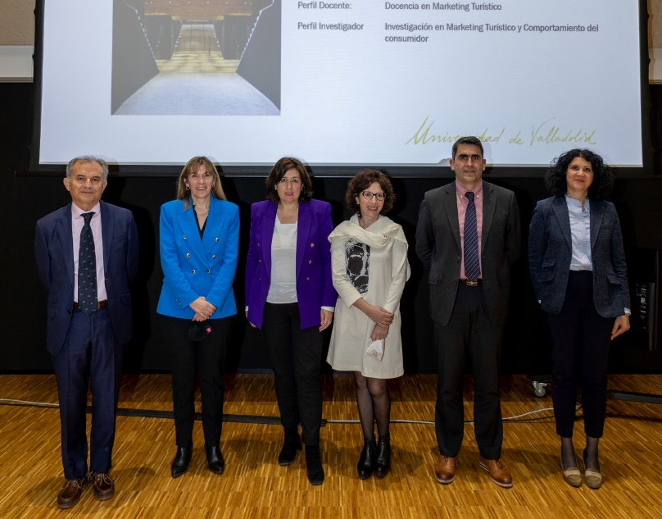

Luis Ignacio Álvarez González nuevo Catedrático del Área de Comercialización e Investigación de Mercados de la Universidad de Oviedo

El pasado jueves 7 de abril de 2022 tuvo lugar el concurso de acceso al cuerpo docente de Catedráticos de Universidad, en el Área de Comercialización e Investigación de Mercados, del profesor D. Luis Ignacio Álvarez González. El acto contó con la comisión evaluadora formada por los profesores Dª Mª José Sanzo Pérez (Universidad de Oviedo), D. Víctor Iglesias Argüelles (Universidad de Oviedo), Dª Carmen Camarero Izquierdo (Universidad de Valladolid), D. Ángel Herrero Crespo (Universidad de Cantabria) y D. Juan A. Trespalacios Gutiérrez (Universidad de Oviedo).

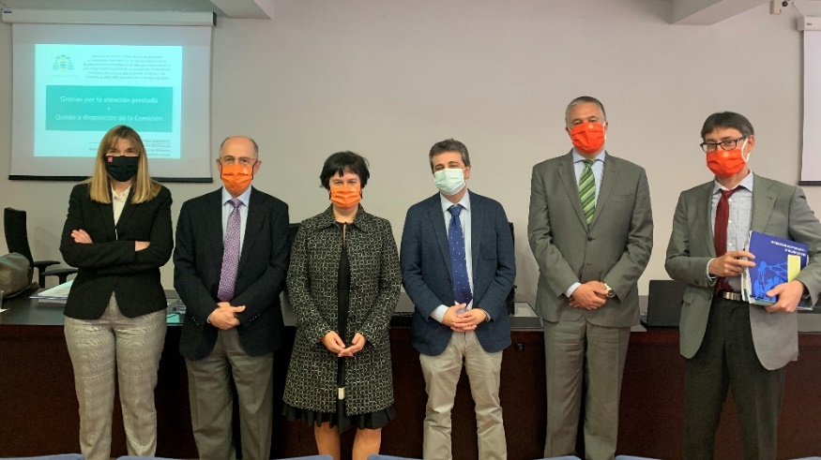

REDES SOCIALES
Recordatorio envío noticias
Os recordamos que podéis enviar vuestras noticias sobre seminarios, call for papers, libros publicados, nombramientos, etc., hasta el día 24 de cada mes para su publicación en este boletín. La dirección de envío es boletin@aemark.org

